**Docker & Selenium Project**

Name: Goraparthi Usha

Employee ID:201383

E-mail: [Goraparthi.Usha@amdocs.com](mailto:Goraparthi.Usha@amdocs.com)

**Introduction**

**What is Docker?**

Docker is an open platform for developing, shipping, and running applications. Docker enables you to separate your applications from your infrastructure so you can deliver software quickly.

Uses

* Fast, consistent delivery of your applications
* Running more workloads on the same hardware
* Running more workloads on the same hardware

**Architecture**

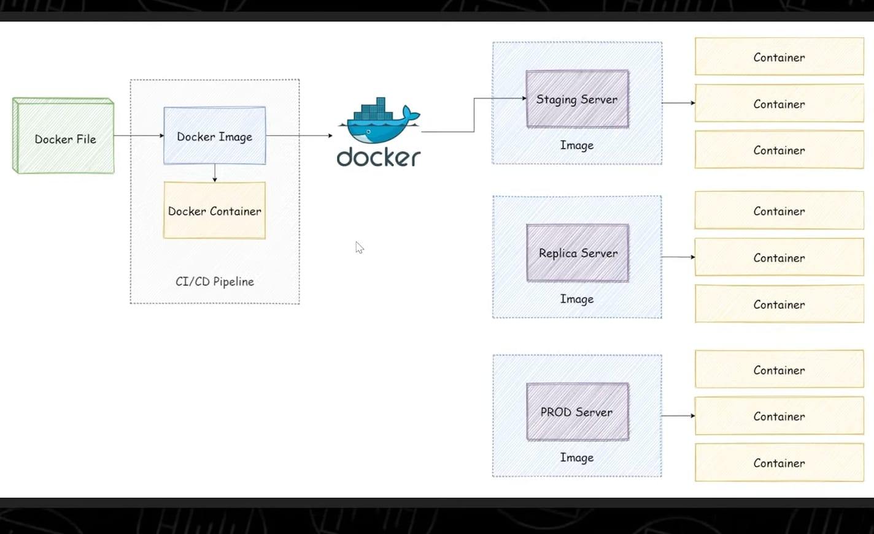

**Code**

Code for Amazon web driver using selenium

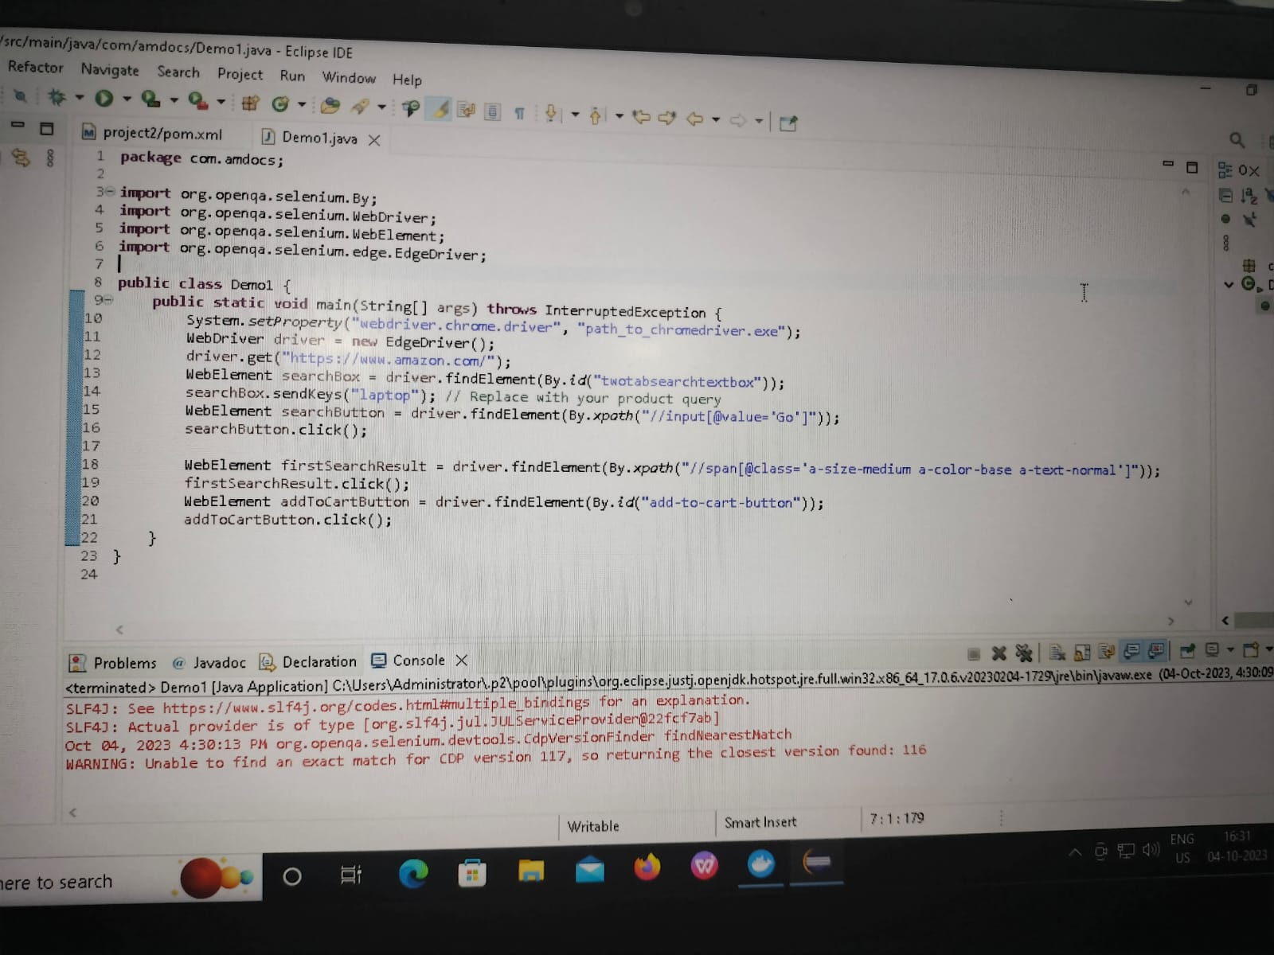

**Output-1**

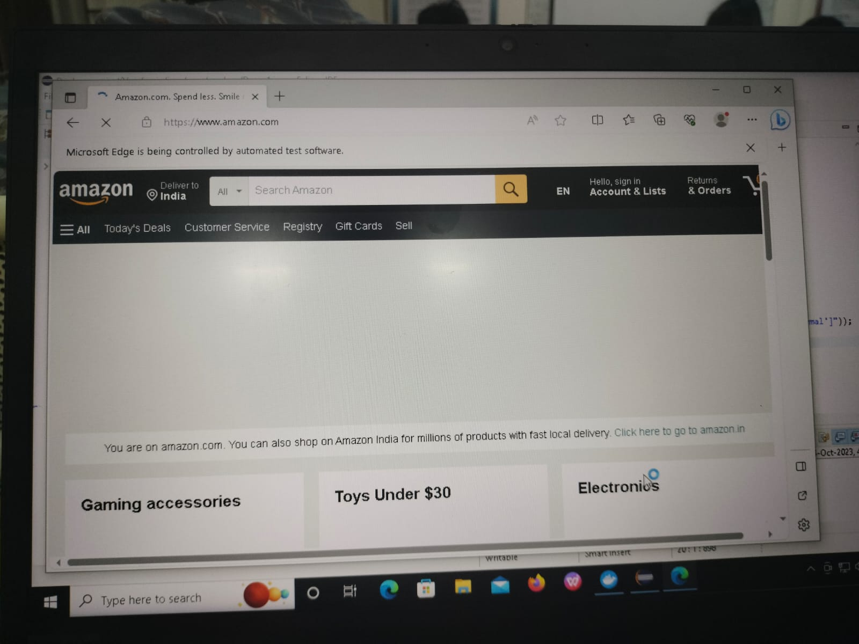

**Output - 2**

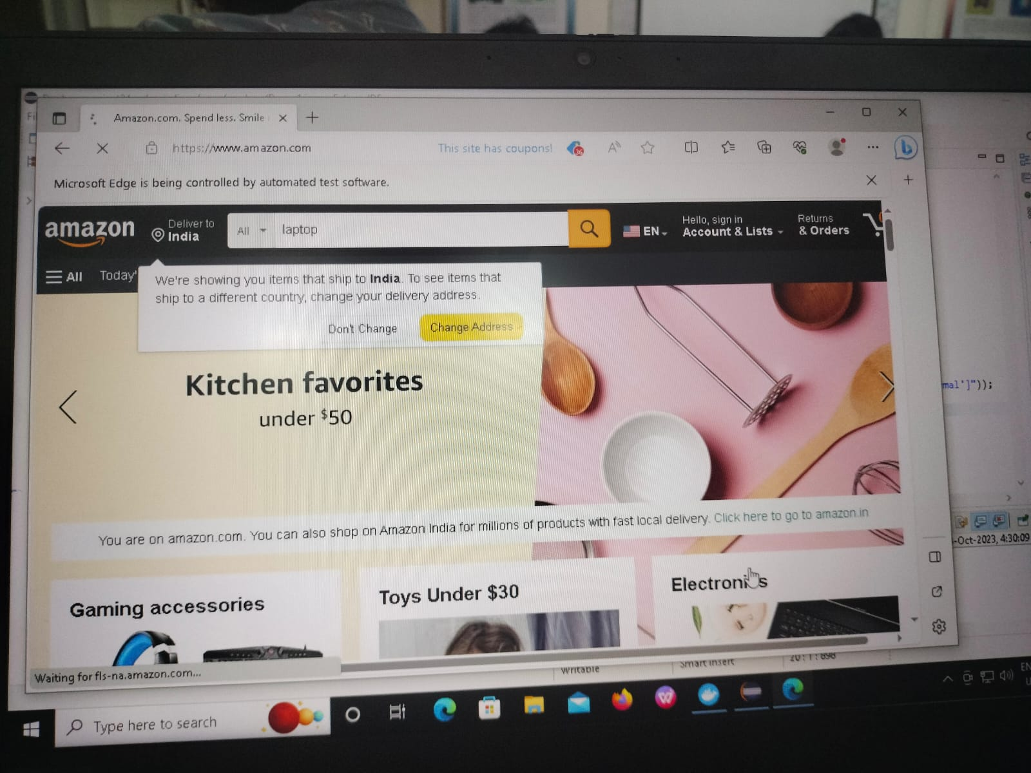

**Output – 3**

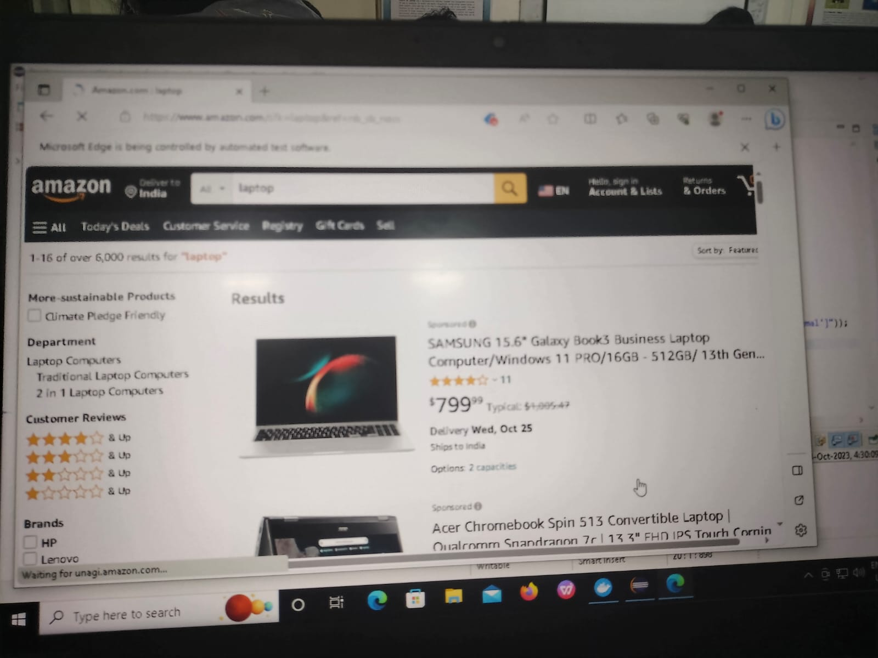

**Output – 4**

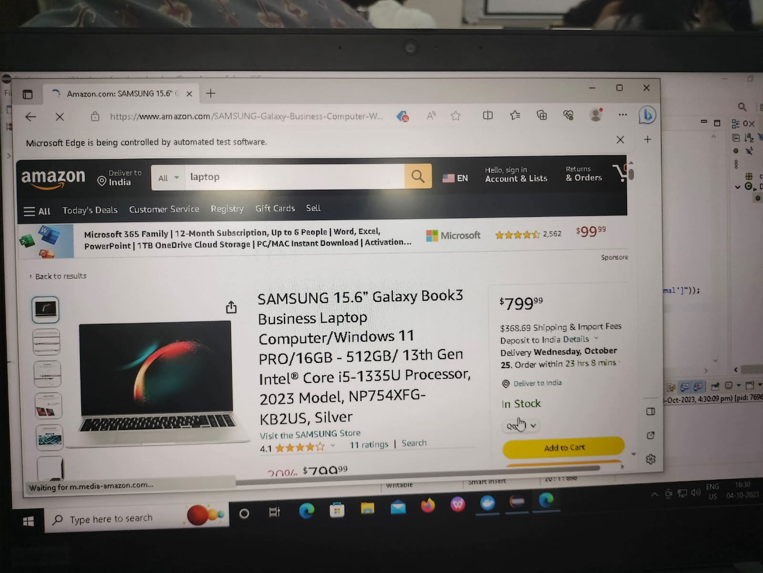

**Output – 5**

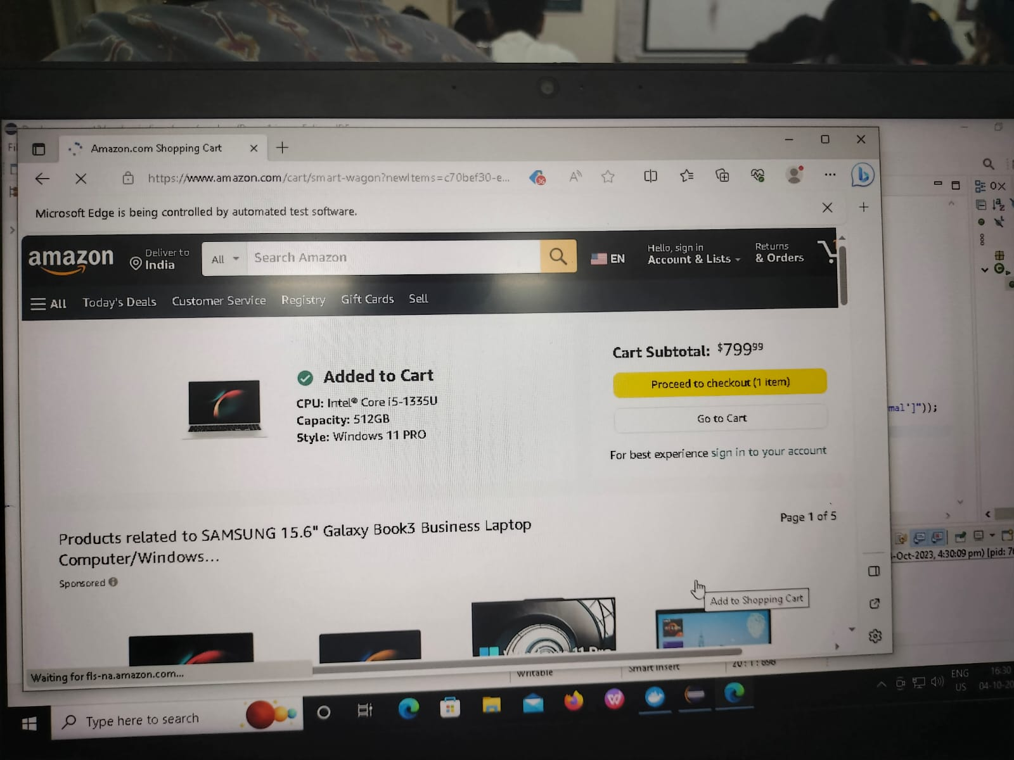

**Creating Spring boot Project**

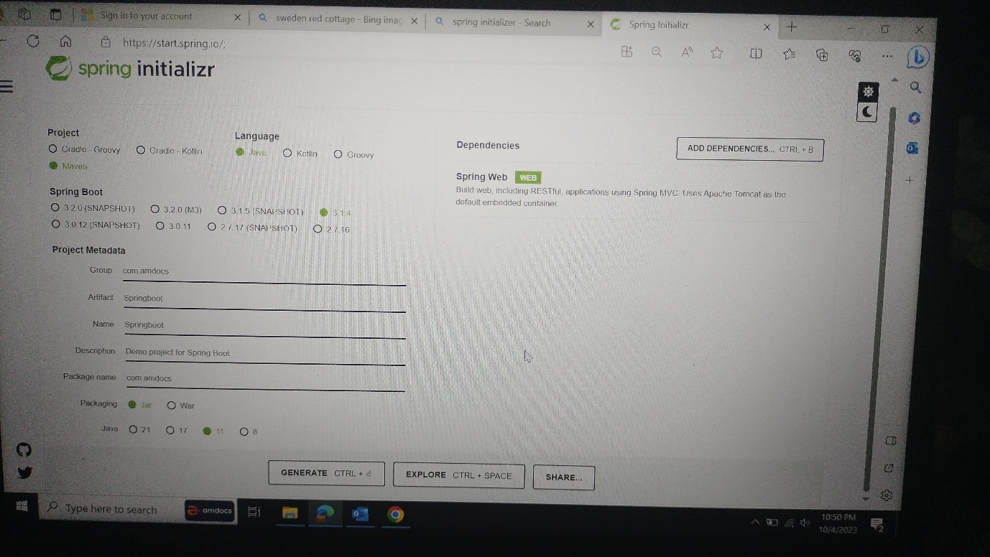

* Create a class as dome1 and import the rest controller and get mapping and return the employee id and employee name

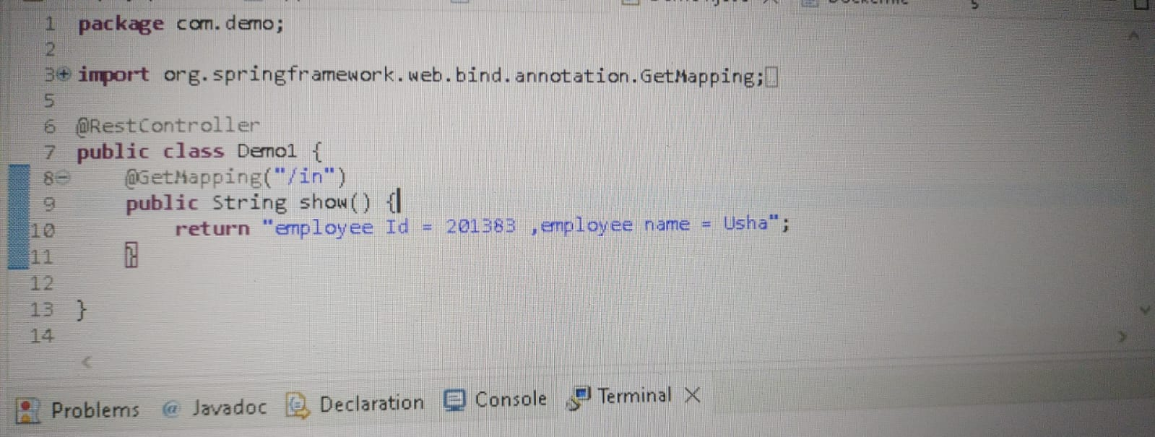

* Go to the form.xml file and write <finalname>project</finalname> In between </plugins> and </build>

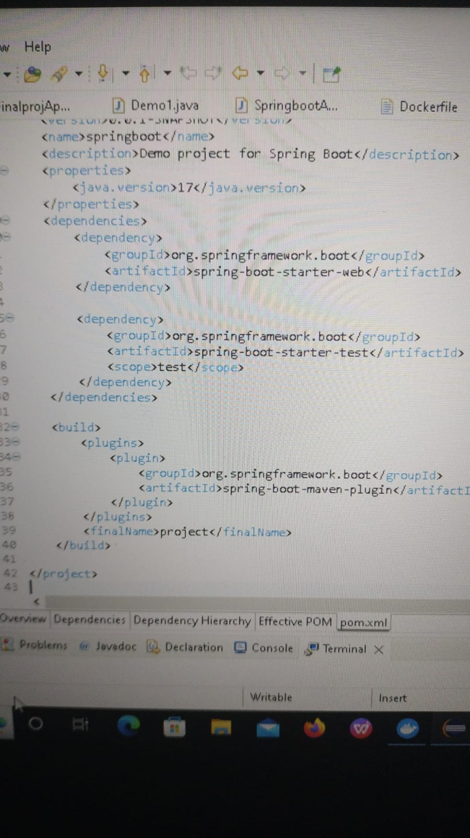

* To create a docker file just right click on the project and go to the file and enter file name as Dockerfile

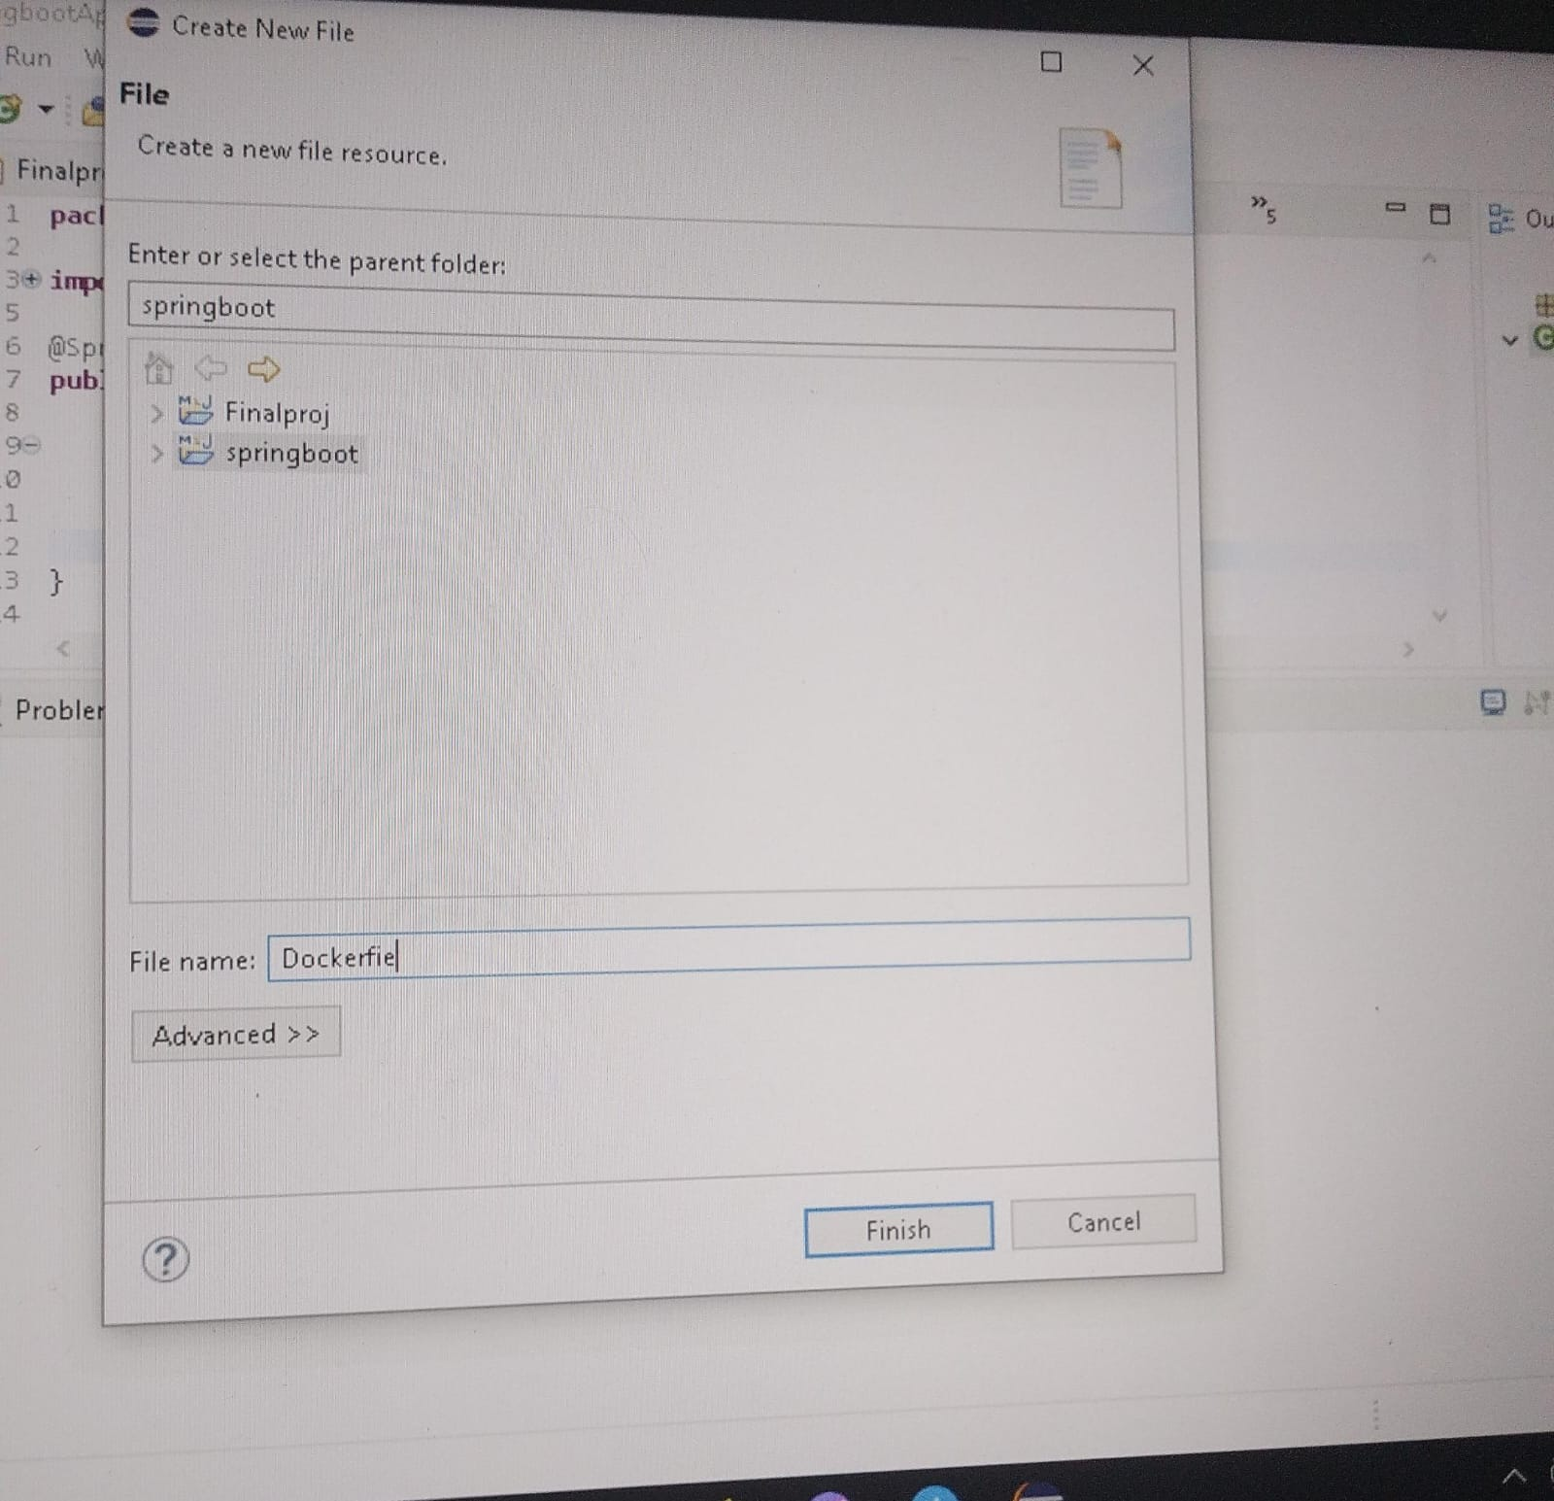

* Click on the Dockerfile and write the code as shown below and save and run

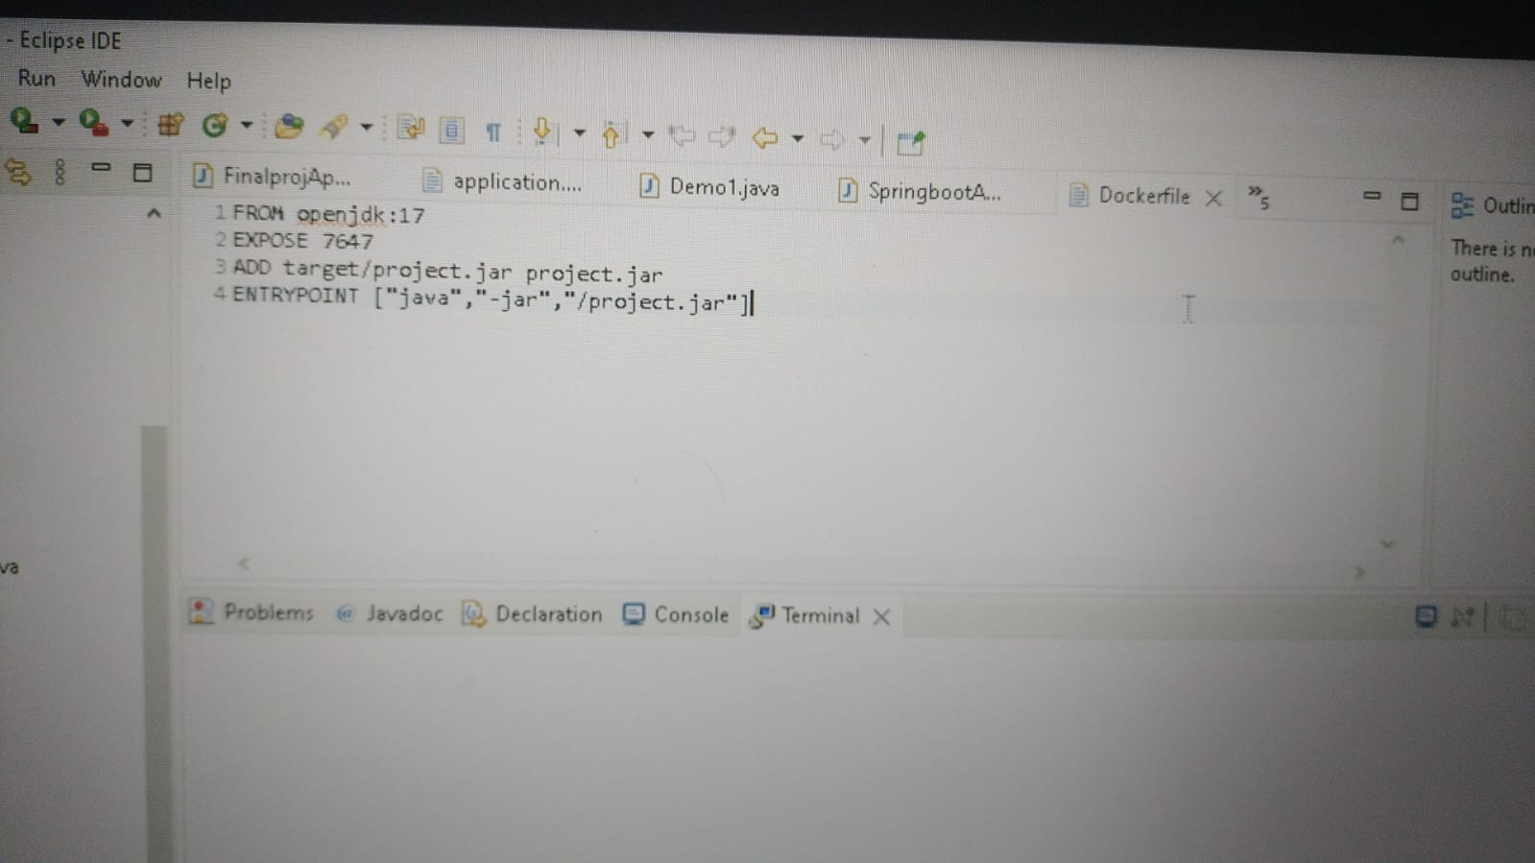

* Generate JAR file by clicking run as Maven Install

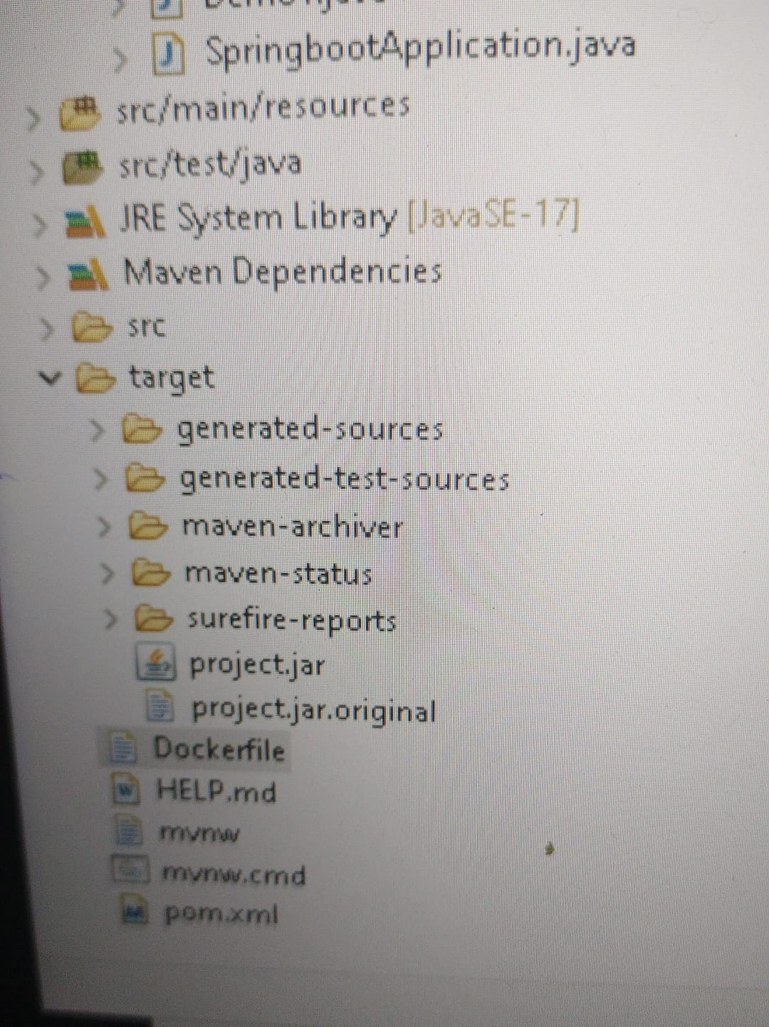

**Dockerizing Project**

Creating Docker Image from JAR file

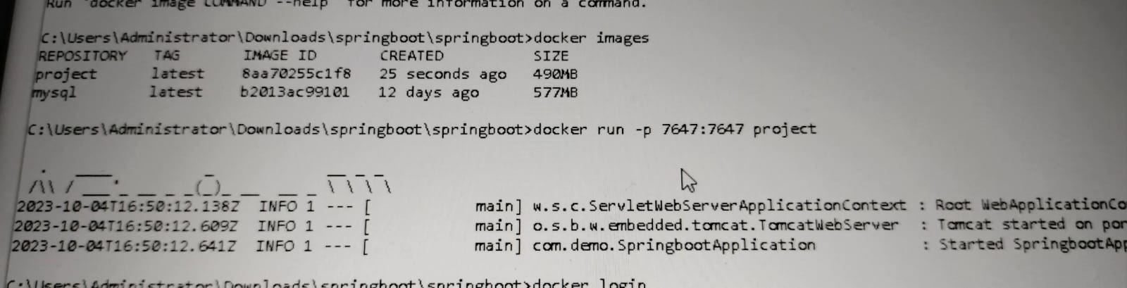

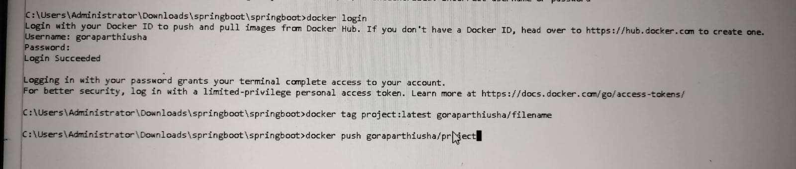

**Output**

